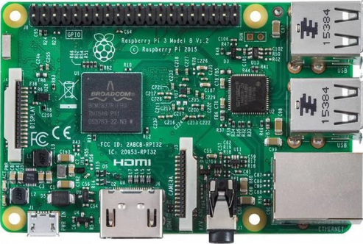

Leader

07

08

07

07

09

10

09

09

10

10

Followers

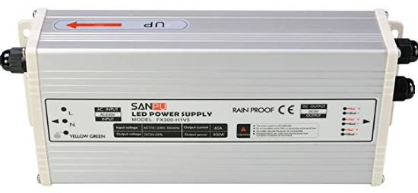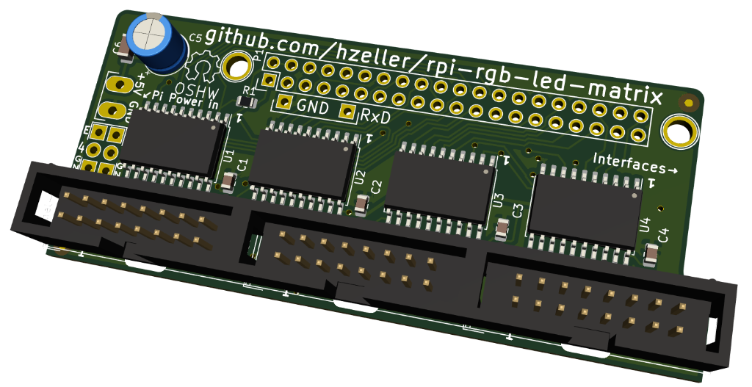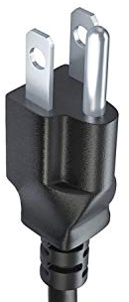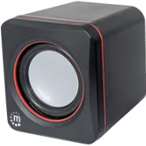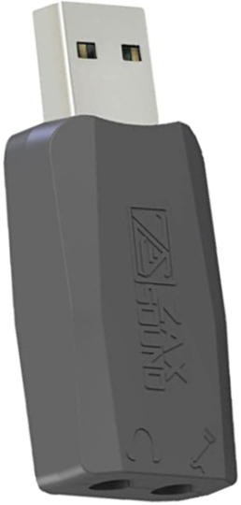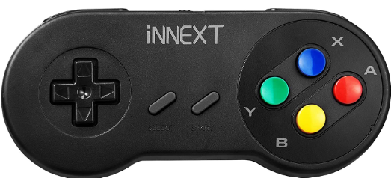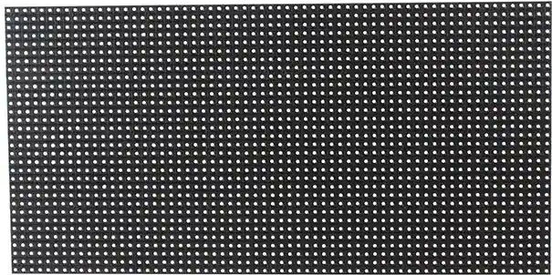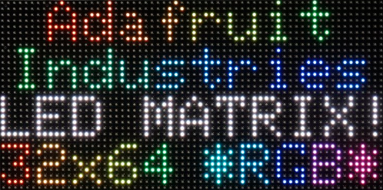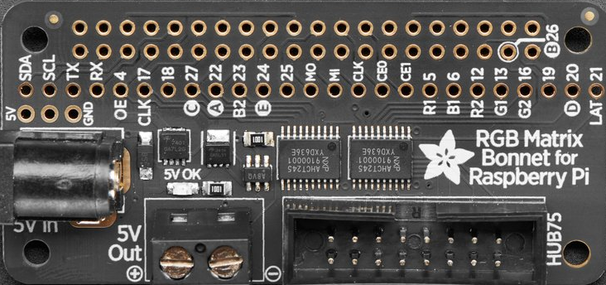

MOUTH = [

[

**'''**

**11..11 .1111.**

**1....1 .1..1.**

**11..11 .1111.**

**1....1 11..11**

**111111 111111**

**..11.. ..11..**

**'''**

], ...

]

MOUTH = image.from_string(MOUTH)

CHARS = {

**'0|1|2|3'** :

**'''**

**.111.. ..1... .111.. .111..**

**1...1. .11... 1...1. 1...1.**

**1..11. ..1... ....1. ....1.**

**1.1.1. ..1... ..11.. ..11..**

**11..1. ..1... .1.... ....1.**

**1...1. ..1... 1..... 1...1.**

**.111.. .111.. 11111. .111..**

**...... ...... ...... ......**

**...... ...... ...... ......**

**'''**,

**'4|5|6|7'** :

**'''**

**...1.. 11111. .111.. 11111...**

**..11.. 1..... 1...1. 1...1...**

**.1.1.. 1..... 1..... ...1....**

**11111. 1111.. 1111.. ...1....**

**...1.. ....1. 1...1. ..1.....**

**...1.. ....1. 1...1. ..1.....**

**...1.. 1111.. .111.. ..1.....**

**...... ...... ...... ........**

**...... ...... ...... ........**

**'''**, ...

}

CHARS = image.from_string(CHARS)

base_frame = Frame()

base_frame.draw_image(10,15, GR.CHARS[*'A'*]) # The letter 'A'

base_frame.draw_text(5,5, GR.CHARS,*'Demonstration'*) # Line of text

base_frame.draw_image(20,25, GR.BIG_BUG[*'standing'*]) # Bug standing

base_frame.draw_image(50,25, GR.BIG_BUG[*'dancing'*][0]) # Bug dancing ...

base_frame.draw_image(70,25, GR.BIG_BUG[*'dancing'*][1]) # ... two animations

direction = 1 # 0=UP, 1=RIGHT, 2=DOWN, 3=LEFT

animation = 0 # 0 or 1 ... two animations

while True:

frame = Frame(base_frame) # Make a copy of the base frame

frame.draw_image(10,60, GR.MOUTH[direction][animation])

hardware.render_frame(frame)

animation = (animation + 1) % 2 # toggle between 0 and 1

time.sleep(0.25)

MOUTH = [

[

'''

11..11 .1111.

1....1 .1..1.

11..11 .1111.

1....1 11..11

111111 111111

..11.. ..11..

'''

], ...

]

MOUTH = image.from_string(MOUTH)

CHARS = {

'0|1|2|3' :

'''

.111.. ..1... .111.. .111..

1...1. .11... 1...1. 1...1.

1..11. ..1... ....1. ....1.

1.1.1. ..1... ..11.. ..11..

11..1. ..1... .1.... ....1.

1...1. ..1... 1..... 1...1.

.111.. .111.. 11111. .111..

...... ...... ...... ......

...... ...... ...... ......

''',

'4|5|6|7' :

'''

...1.. 11111. .111.. 11111...

..11.. 1..... 1...1. 1...1...

.1.1.. 1..... 1..... ...1....

11111. 1111.. 1111.. ...1....

...1.. ....1. 1...1. ..1.....

...1.. ....1. 1...1. ..1.....

...1.. 1111.. .111.. ..1.....

...... ...... ...... ........

...... ...... ...... ........

''', ...

}

CHARS = image.from_string(CHARS)

base_frame = Frame()

base_frame.draw_image(**10**,**15**, GR.CHARS['A']) # The letter 'A'

base_frame.draw_text(**5**,**5**, GR.CHARS,'Demonstration') # Line of text

base_frame.draw_image(**20**,**25**, GR.BIG_BUG['standing']) # Bug standing

base_frame.draw_image(**50**,**25**, GR.BIG_BUG['dancing'][**0**]) # Bug dancing ...

base_frame.draw_image(**70**,**25**, GR.BIG_BUG['dancing'][**1**]) # ... two animations

direction = **1** # 0=UP, 1=RIGHT, 2=DOWN, 3=LEFT

animation = **0** # 0 or 1 ... two animations

**while** True:

frame = Frame(base_frame) # Make a copy of the base frame

frame.draw_image(**10**,**60**, GR.MOUTH[direction][animation])

hardware.render_frame(frame)

animation = (animation + **1**) % **2** # toggle between 0 and 1

time.sleep(**0.25**)